📁 1. Large Office Series
Suitable for single-phase power environments, ideal for daily bulk document shredding in office and corporate settings.
🧩The main specifications of our large office series shredders are as follows:
🆔Model | Top-Selling Models for Various Application Scenarios  Featured Models: YD-23026C, YD-3120C, YD-310CC, YD-418CC, YD-338CC-HD, YD-448CC, YD-PSJ300ES, YD-PSJ300
📥Feed Width (mm) | Various Feed Width Options for Office and Industrial Use  Maximum Custom Size: 900mm  Common Sizes: 240mm / 310mm / 400mm / 460mm / 500mm / 600mm
✂️ Cut Size | Customizable Output Size – From Office Use to High-Security Destruction  Minimum Particle Size: 0.6×2.9mm / 0.7×3.5mm / 1×1mm (powder-grade)  Common Sizes: 1×5cm, 5.8×50mm, 4×40mm, 2×15mm, 1×10mm
📑 Max Sheets | Handles Light to Heavy Shredding Workloads Efficiently  Max Capacity: 60–100 sheets per pass  Typical Capacity: 25 / 35 / 45 sheets (70g A4 paper)
⚖️Weight (kg) | Covers Lightweight Units to Entry-Level Industrial Machines  Typical Weight Range: 15kg – 250kg
🔌Power | High-Performance Power Output for Various Operational Demands  Typical Power Range: 580W – 2.6KW  Maximum Power: 3KW
📏 L×W×H (mm) | Flexible Body Size – Customizable to Fit On-Site Requirements  Compact sizes suitable for office doors and elevators  Custom dimensions available with engineering drawings provided
🗑️Bin(L) | Large Waste Bin – Reduces Cleaning Frequency  Standard Capacities: 50L / 120L / 150L / 160L  Optional larger volumes available upon request
💰Price (USD) | Flexible Pricing – Covers Office to Professional Applications  Typical Price Range: ¥1,500 – ¥50,000  Please contact us for exact quotations and volume discounts
📂 High-Power Office Shredders
📌 Featured Models：YD-23026, YD-3120, YD-418CC, YD-428CC, YD-310CC26, YD-338CC
📂 Dual-Entry Funnel Shredders
📌 Featured Models：YD-400CC-HD, YD-458CC-HD, YD-448CCM, YD-PSJ300ES, YD-PSJ250ES2, YD-PSJ250ES3
🔍Quick Selection快速选型
🖼️Front View | 📥Feeding Inlet | 🆔Model |  | ✅ Features | 💰Price USD
📂 High-Power Office Shredders
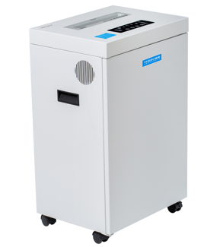 | 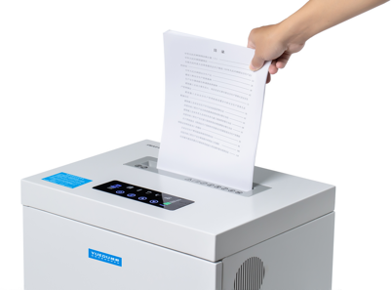 | YD-23026C  YD-23026M  YD-23026M2 |  |  | 415  439  475
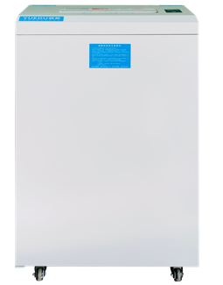 | 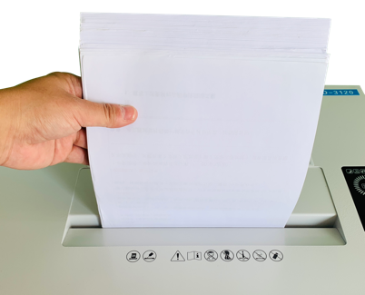 | YD-3120S  YD-3120C  YD-3120M  YD-M2405 |  | 🗑️ 120L | 991  1398  1668  245
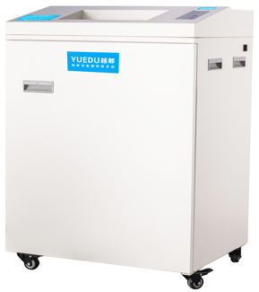 | 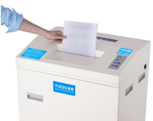 | YD-310CC  YD-310CCM |  | 🗑️ 150L | 2688  2829
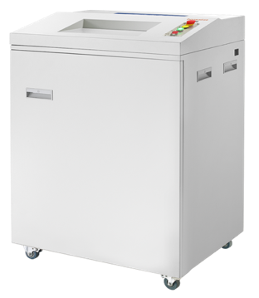 | 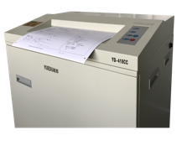 | YD-418CC  YD-428CC |  | 📥 42cm | 4020  5395
📂 Dual-Entry Funnel Shredders
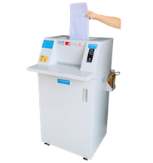 | 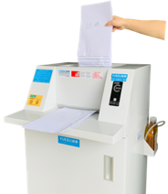 | YD-338CC26  YD-338CC-HD  YD-338CCM |  |  | 5713  7110  7140
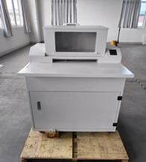 | 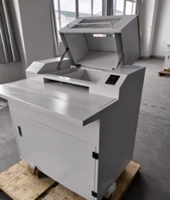 | YD-448CC  YD-448CCM |  | 📥Feed 44cm | 9715  11828
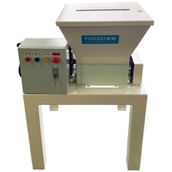 | 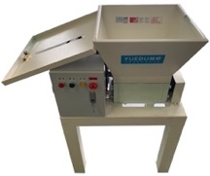 | YD-PSJ300ES |  | ✂️hard drives, PCBs, paper-bound files. | 2853
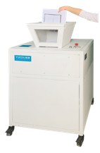 | 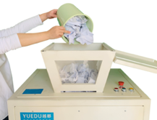 | YD-PSJ300-2P  YD-PSJ300-3P |  | 🗑️ 160L | 5715  8378

➕ Custom Cases更多定制案例
🖼️Front View | 📥Feeding Inlet | 🆔Model |  | 💰Price (USD)
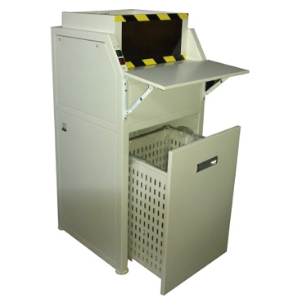 | 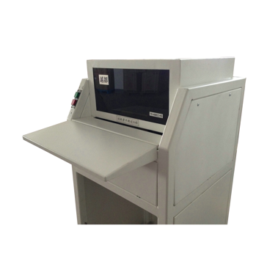 | YD-400CC-HD |  | 4115
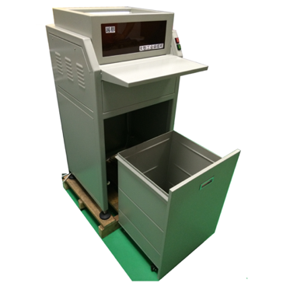 | 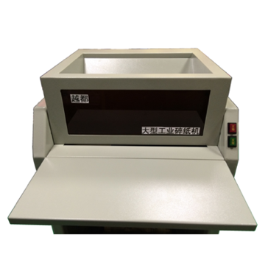 | YD-458CC-HD |  | 5545
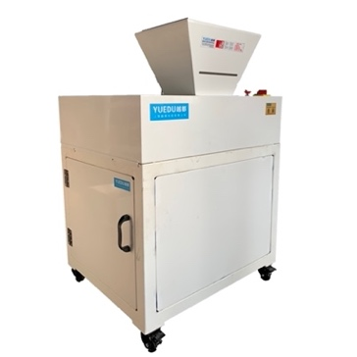 | 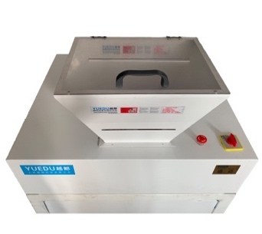 | 📄 YD-PSJ250ES2 |  | 4490
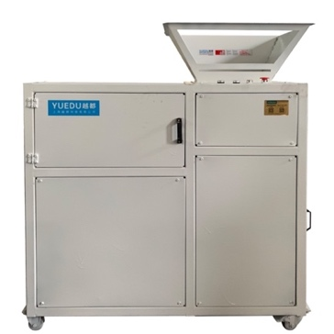 | 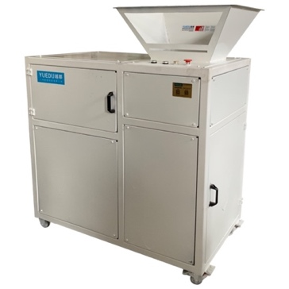 | 📄 YD-PSJ250ES3 |  | 5688

📄 YD-23026
🖼️Product Overview
Fig. 1: Full View  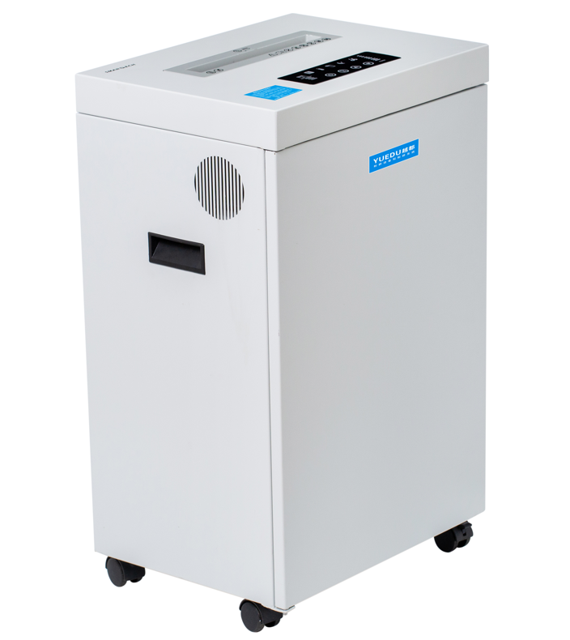 | Fig. 2: Feeding View  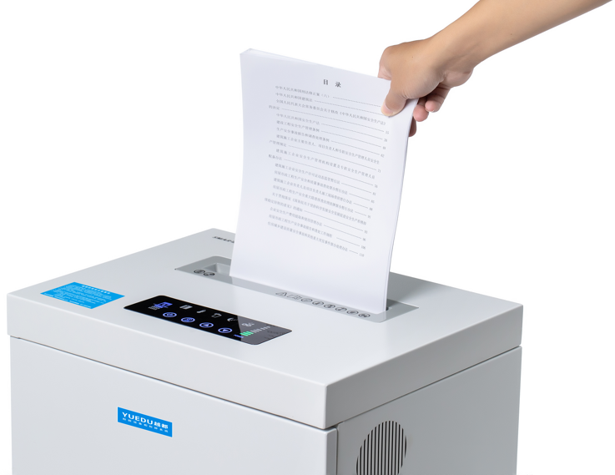 | Fig. 3: Internal View  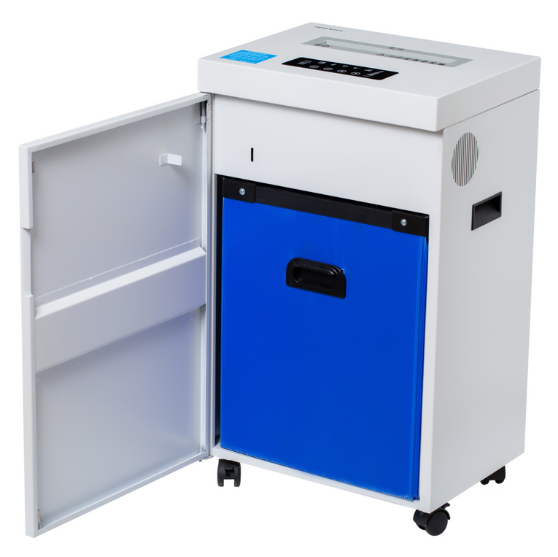
✅ Key Features
● 🔁 Continuous operation for 60 minutes
● 📄 Up to 6,000 sheets/hour (22 kg)
🧩 Application Scenarios
🏢 Offices 🏦 Banks 💼 Finance 🗂️ Archives 👨‍💼 Executives
✂️ Shreddable Materials
📄 A4 Paper 📚 Magazines 💳 Cards 💿 CDs/DVDs 🧾 Receipts
🔧 Technical Specifications:
🆔Model | YD-23026C | YD-23026M | YD-23026M2 | Fig. 4: Control Panel View  (Panel with dynamic load display)  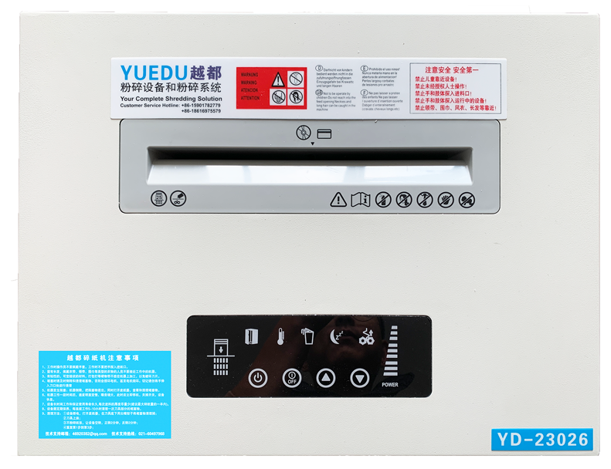
📥Feed Width (mm) | 240mm | 240mm | 240mm
✂️ Cut Size | 3.9*38mm | 2*15mm | 2*10mm
📑 Max Sheets | 25-32 | 15 | 18
⚖️Weight (kg) | 30kg | 30kg | 30kg
🔌Power | 580W | 600W | 600W
📏 L×W×H (mm) | 430*330*710 | 430*330*710 | 430*330*710
🗑️Bin(L) | 50L | 50L | 50L
💰Price (USD) | 415 | 439 | 475

📄 YD-3120C / M2405 / YD-2760
🖼️Product Overview
Fig. 1: Full View  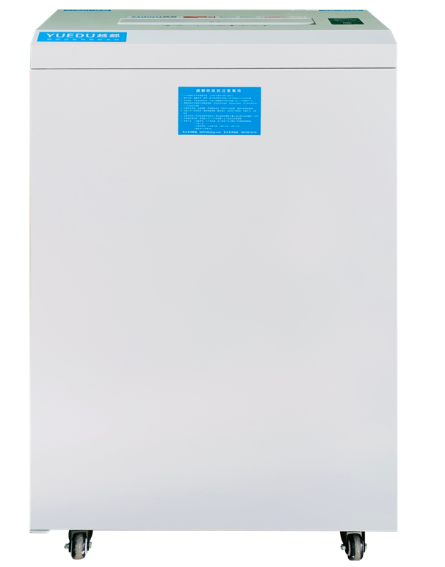 | Fig. 2: Feeding View  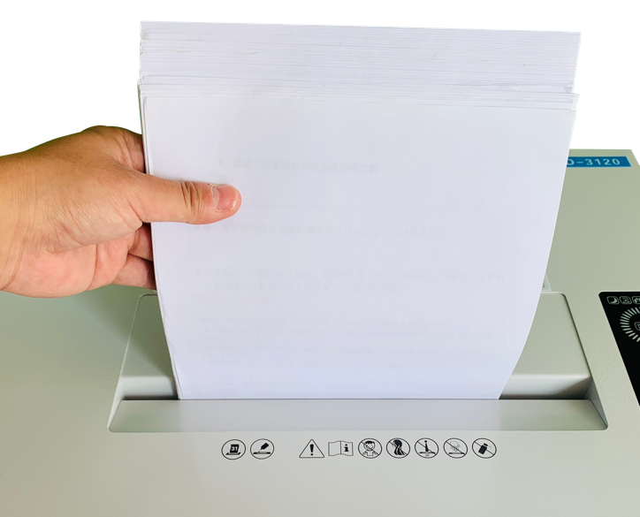 | Fig. 3: Internal View  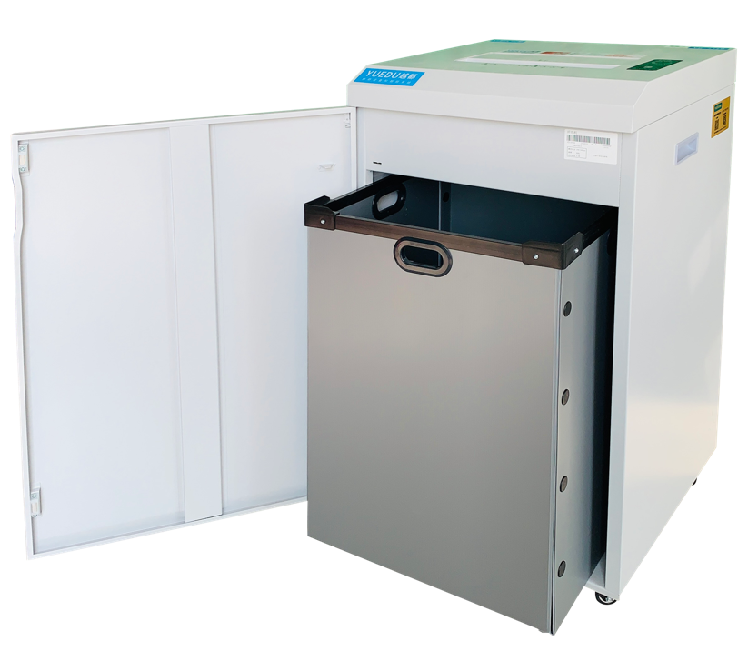
Fig. 4: Control Panel View (Panel with dynamic load display)
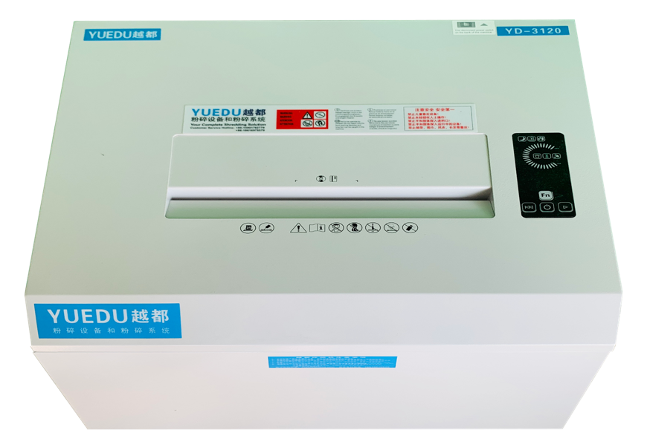 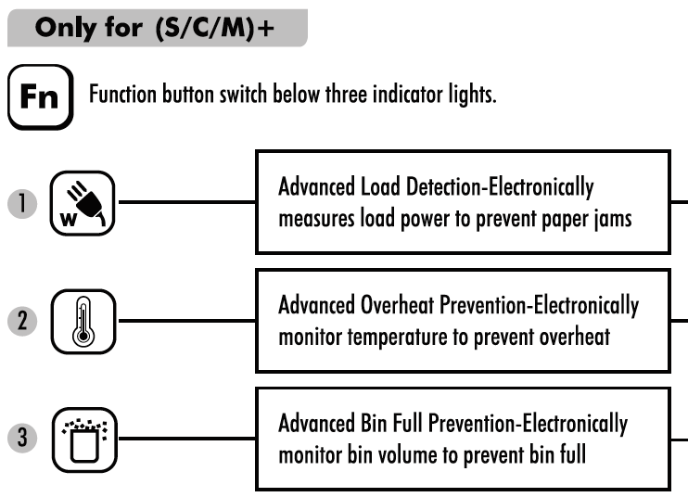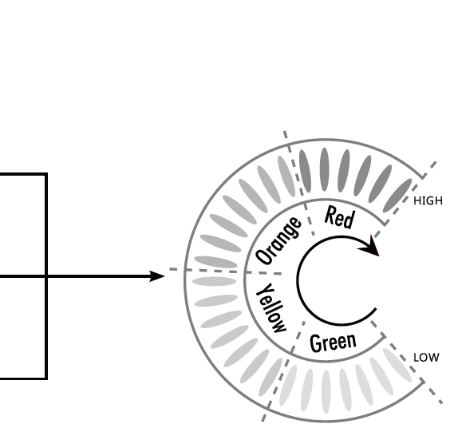
✅ Key Features
● 🔁 Continuous operation
● 🗑️ 120L BIN
🔧 Technical Specifications:
🆔Model | YD-2760 | YD-3120S | YD-3120C | YD-3120M | YD-M2405
📥Feed Width (mm) | 270mm | 310mm | 310mm | 310mm | 220mm
✂️ Cut Size | 3.8*38mm | 3.8mm or 5.8mm | 3.8*38mm | 2*8mm | 1*2mm
📑 Max Sheets | 20-25 | 26-32 (or 40) | 20-25 | 15-18 | 4-5
⚖️Weight (kg) | 45kg | 45kg | 45kg | 45kg | 45kg
🔌Power | 900W | 900W | 900W | 900W | 480W
🔁Continuous | Yes | Yes | Yes | Yes | 60min
📏 L×W×H (mm) | 480*396*706 | 532*465*910 | 532*465*910 | 532*465*910 | 470*396*706
🗑️Bin(L) | 62L | 120L | 120L | 120L | 60L
💰Price (USD) | 825 | 991 | 1397 | 1668 | 645

📄 YD-310CC / YD-418CC / YD-428CC
🖼️Product Overview
Fig. 1: Full View  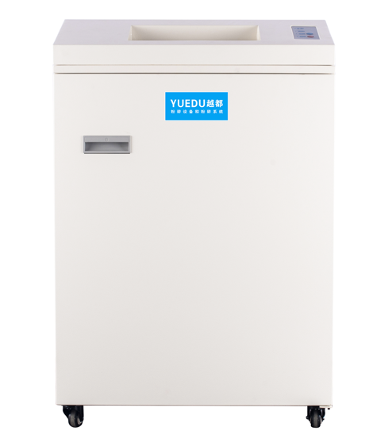 | Fig. 2: Feeding View  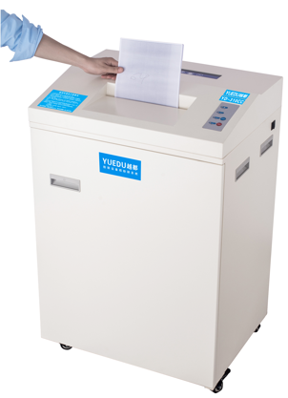 | Fig. 3: Internal View  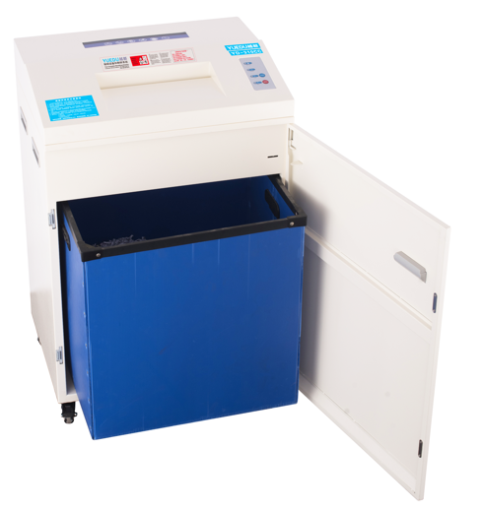
✅ Key Features

● 🔁 Continuous operation over 3 hours
● 🗑️ 150L BIN
🔧 Technical Specifications:
🆔Model | YD-310CC | YD-310CCM | YD-418CC | YD-428CC | 图4 YD-418CC机型碎图纸  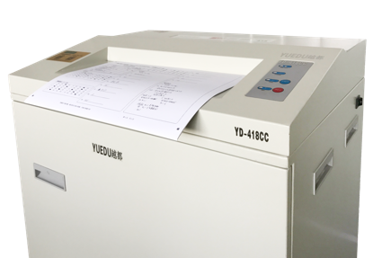
📥Feed Width | 310mm | 310mm | 418mm | 428mm
✂️Cut Size | 3.8*39mm | 1.9*15mm | 3.8*39mm | 5.8*45mm
📑Max Sheets | 25-35 | 16-20 | 25-32 | 55-65
⚖️Weight | 93kg | 95kg | 97kg | 110kg
🔌Power | 1.2KW | 1.2KW | 1.3KW | 2KW | 图5 YD-428CC整机图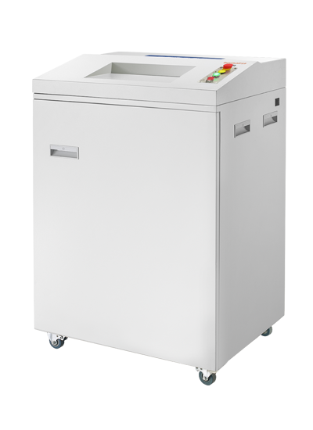
🔁 Continuous | 3 hours | 3 hours | 3 hours | Continuous
📏 L×W×H (mm) | 620*480*1070mm | 620*480*1070mm | 620*480*1070mm | 800*650*1150mm
🗑️Bin(L) | 150L | 150L | 150L | 260L
💰Price (RMB) | 18800 | 19800 | 28140 | 37750
💰Price (USD) | 2688 | 2829 | 4020 | 5395

📄YD-338CC Series
🖼️ Product Overview
Fig. 1: Full View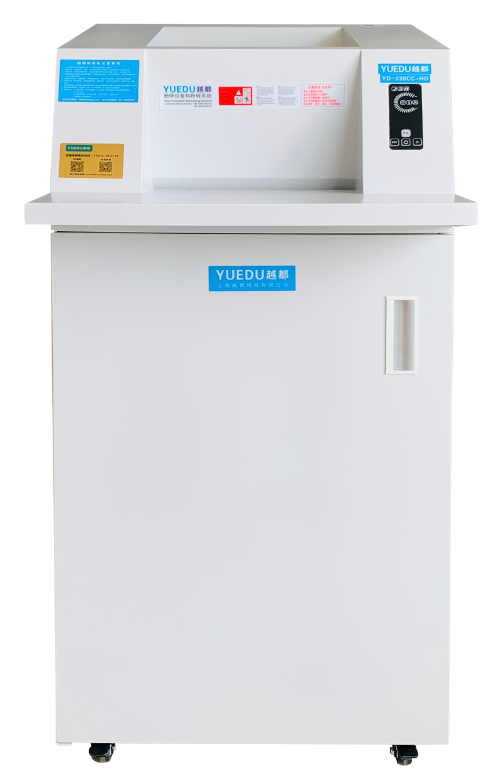 | Fig. 2: Feeding View  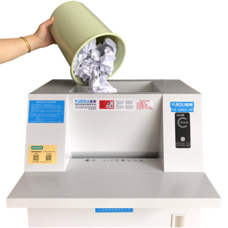 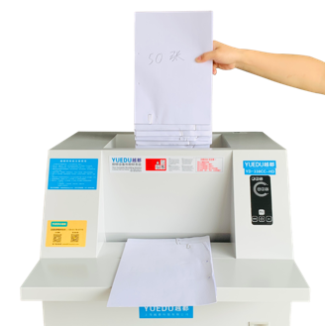  Fig. 3: Self-Lubricating Blades  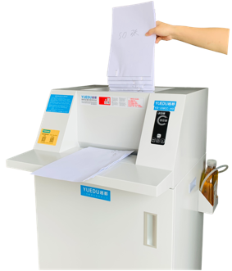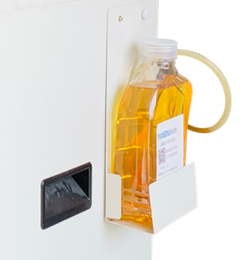  Fig. 4: Integrated Steel Cutter – 10-Year Warranty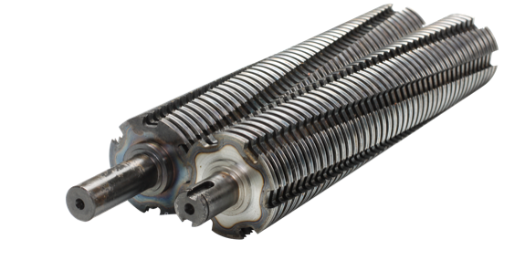
✂️ Shreddable Materials
📄 A4 Paper 📚 Magazines 💳 Cards 💿 CDs/DVDs 🧾 Receipts
🔧 Technical Specifications：
🆔Model | YD-338CC26-HD | YD-338CC40-HD | YD-338CC-HD | YD-338CCM
📥Feed Width (mm) | Flat feed platform width: 600 mm, hopper-style inlet width: 330 mm
✂️ Cut Size | 3.8*35mm | 3.8*38mm | 3.8*38mm | 1.8*15mm
📑 Max Sheets | 26-38(70g A4) | 40-48(70g A4) | 50-60(70g A4) | 25-35(70g A4)
⚖️Weight (kg) | 120kg
🔌Power | 1.5KW | 1.8KW | 2.0KW | 1.8kw
📏 L×W×H (mm) | 600*492*1204mm
🗑️Bin(L) | 130L
📄Paper Capacity | 789kg | 900kg | 1200kg | 750kg
💳Card Capacity | 60000 sheets | 50000 sheets | 65000 sheets | 35000 sheets
💿Disc Capacity | 100000 sheets | 120000 sheets | 150000 sheets | 75000 sheets
💰Price (USD) | 5713 | 6268 | 7110 | 7140

📄 YD-448CCM Mid-Security Office Shredder
🆕 Dual-Feed Shredder with Large Bin – Built for Office Efficiency & Security
🖼️ Product Overview
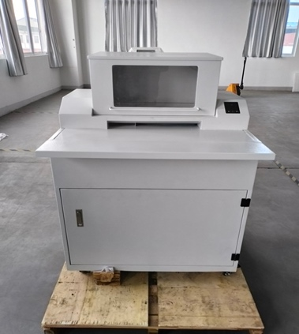 | 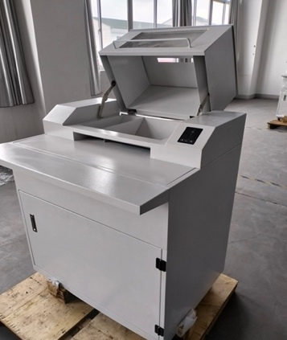 | 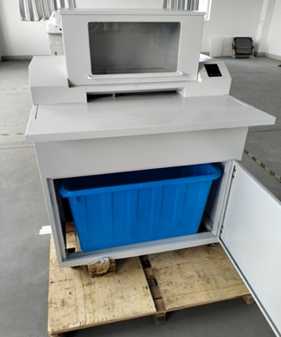 | 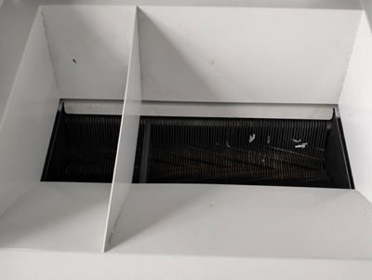
Front View | Right Side View | Safe Feeding Inlet | Fully Enclosed Waste Bin
✨ Highlights：
🔹 Dual Input Design  Top Cover Inlet: for bulk-bound reports & thick documents  Front Slot Inlet: for everyday papers and A4 sheets  🔹 Micro-Cut Security (2×15mm)  Shreds 40–60 sheets per pass  Meets EU P-5 to P-6 security levels  Suitable for financial, legal, and classified document disposal | 🔹 Powerful + Quiet  2.2KW motor supports continuous 3+ hours operation  Quiet at only 55dB – ideal for shared office environments  🔹 160L Extra-Large Bin  Easy-open front cabinet for fast emptying  🔹 Optimized for Offices  Ideal for government departments, accounting teams, and secure workspaces
🌍Preferred by Industry Leaders
The first choice for multinational corporations, industry leaders, and Fortune Global 500 enterprises.
🔧 Technical Specifications:
🆔Model | YD-448CC | YD-448CCM
📥Feed Width (mm) | 448mm | 448mm
✂️ Cut Size | 3.9*45mm | 1.9*15mm
📑 Max Sheets | 50-70 (70g, A4) | 40-60 (70g, A4)
⚖️Weight (kg) | 258kg | 258kg
🔌Power | 2.2KW | 2.2KW
📏 L×W×H (mm) | 1322*877*790mm | 1322*877*790mm
🗑️Bin(L) | 160L | 160L
💰Price (USD) | $9,715 | $11,828

📄 YD-PSJ300ES
🖼️ Product Overview
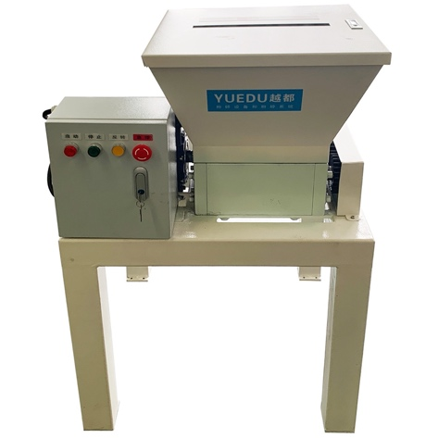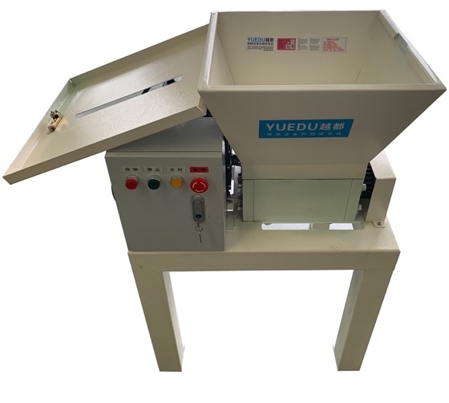
✂️ Shreddable Materials
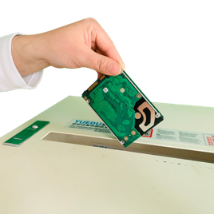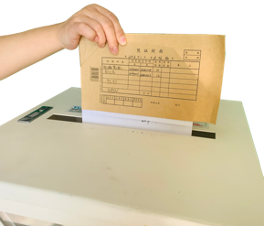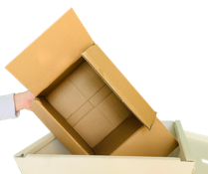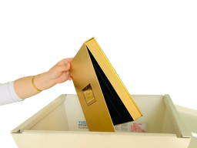

🔧 Technical Specifications
🆔Model | YD-PSJ300ES
📥Feed Width (mm) | 500*380mm | Fig. 4: L×W×H (mm)  Fits through office doors and elevators 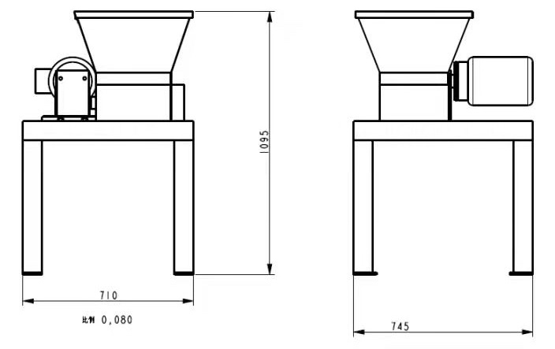
✂️ Cut Size | 1*5cm
📑 Max Sheets | 60-130
⚖️Weight (kg) | 250kg
🔌Power | 2.2KW / 380V
🔁Continuous | 24 hours
📏 L×W×H (mm) | 850*700*1350mm
🗑️Bin(L) | 160L
💰Price (RMB) | 19970
💰Price (USD) | 2853

📄 YD-PSJ300 Series
🖼️ Product Overview
Fig. 1: Full View | Fig. 2: Front View | Fig. 3: Feeding View  (🔐 Hopper with Auto-Lock)  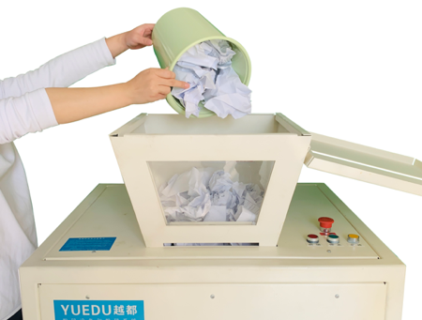
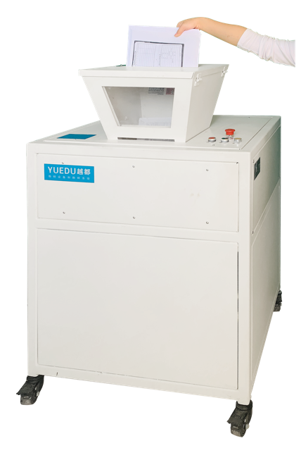 | 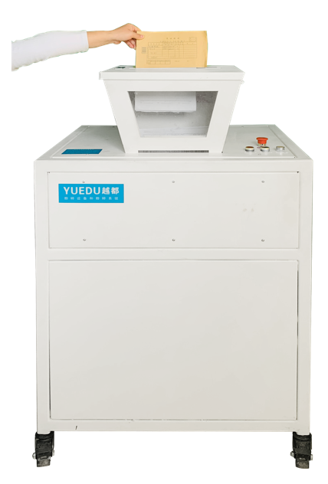
✅ Key Features
shredding of diverse materials such as hard drives, PCBs, and paper-bound files.
✂️ Shreddable Materials
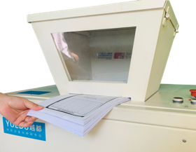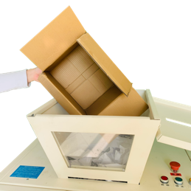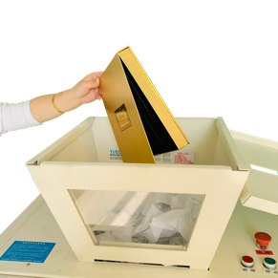
🔧 Technical Specifications
🆔Model | YD-PSJ300 2P1.5KW | YD-PSJ300 3P2.2KW
📥Feed Width | 500*380mm | 500*380mm | Fig. 4: L×W×H (mm)  Fits through office doors and elevators 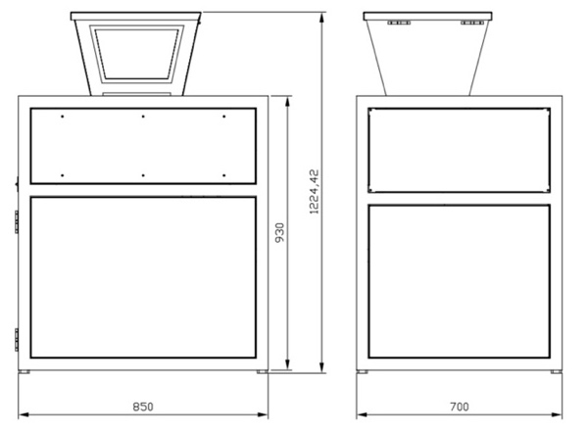
✂️ Cut Size | 1*5cm | 1*5cm
📑 Max Sheets | 40-70 | 60-130
⚖️Weight (kg) | 250kg | 250kg
🔌Power | 1.5KW / 220V | 2.2KW / 3 phase 380V
🔁Continuous | 24 hours | 24 hours
📏 L×W×H (mm) | 850*700*1350mm | 850*700*1350mm
🗑️Bin(L) | Waste Chamber 400L  Waste Bin 160L | Waste Chamber 400L  Waste Bin 160L
💰Price (USD) | 5715 | 8378

Customizable sizes. Common options: 5.8×50mm, 4×40mm, 2×15mm, 1×10mm.
Customizable sizes. Common options: 5.8×50mm, 4×40mm, 2×15mm, 1×10mm.

